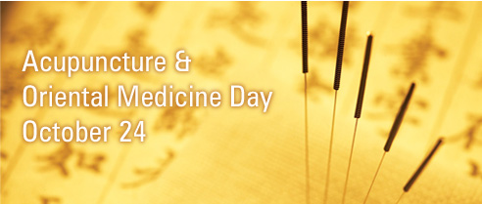
OCTOBER: Come Celebrate With Us!

You are invited to join us as we celebrate Acupuncture & Oriental Medicine Day! In an effort to increase public awareness of the progress, promise, and benefits of acupuncture and Oriental medicine, AOM day is observed in the United States, Canada and Mexico by professional associations, research organizations and educational institutions

This will be a weeklong celebration (Oct 22-Oct 26) and everyone is invited! We will be celebrating with our new and current patients by offering the following great opportunities:

- $20 off the new patient fee on regular acupuncture

- Half Price Acupuncture (only $35) for private acupuncture sessions to quit smoking. This awesome opportunity is open to NEW and CURRENT patients. You can even come all five days to help kick the habit!

- Free Initial Adjustment for NEW Chiropractic patients on Tuesday and Thursday morning.

- Enter to Win a FREE acupuncture treatment ($69 Value). With each acupuncture or chiropractic session you receive a chance to win one free treatment during the month of November.

We will also have refreshments and snacks

