September 3rd 2010

Dr. Herbert Lau, Acupuncturist, Will Receive a 2010 NYS “Second-Half Champion” Award.

Dr. Herbert Lau, Acupuncturist, Certified Herbologist and owner of King’s Acupuncture & Wellness Center in East Amherst, has been selected to receive a “Second-Half Champion” Award for New York State. The annual award, sponsored by Wells Fargo Advisors, celebrates individuals who inspire us after the age of 50.

Dr. Lau qualifies for the award as someone who has repurposed his life through an extraordinary transformation after the age of 50, has achieved remarkable personal goals, has made a significant contribution to society and has used the second half of his life for a purpose completely different from the first half.

In the first half of his life Dr. Lau worked as a Clinical Chemist/Laboratory Director at Sisters of Charity Hospital and Quest Clinical Laboratories in Buffalo. At the age of 55 Dr. Lau was inspired by acupuncturist, Dr. King, to return to school and study Acupuncture and Oriental Medicine at Mercy College in NYC.

Dr. and Mrs. Lau, along with their immediate family, will attend the NYS 2010 Second-Half Champion Award Ceremony on October 13th in Long Island, NY.

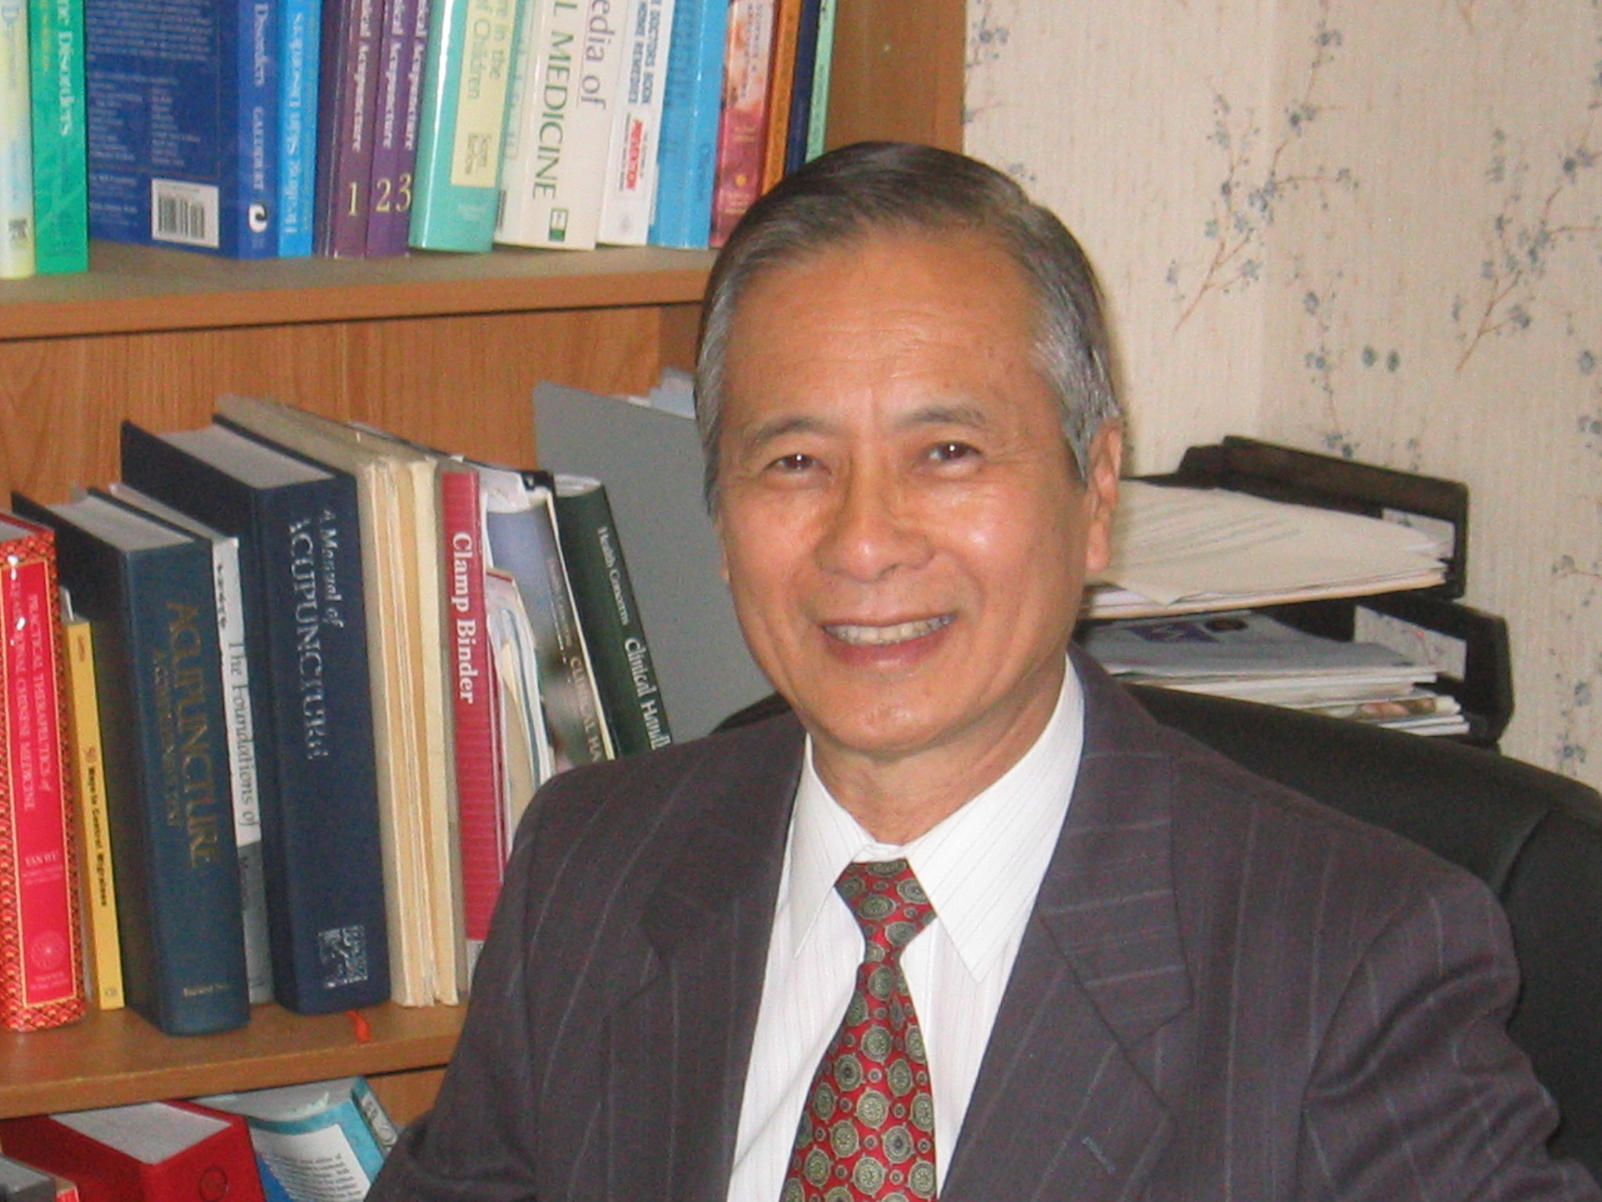


September 3rd 2010

Dear Friends and Family:

I am pleased to tell you that Wells Fargo Advisors is honoring me as a Second-Half Champions® winner. Please accept this invitation to help me celebrate at the awards ceremony.

Wednesday, October 13, 2010
6 p.m.
Tilles Center for the Performing Arts
720 Northern Boulevard, Greenvale, NY (Long Island, NY)

TICKET REGISTRATION AND EVENT INFORMATION
To register for your complimentary tickets, please visit 2HCevents.com or call 1-800-435-4105. These resources will also provide you with answers to frequently asked questions regarding the Second-Half Champions awards ceremony including attire, parking, food and beverage and wheelchair accessibility.

MIKE RAYBURN
The awards ceremony includes musical and comedic entertainment by Mike Rayburn, the World’s Funniest Guitar Virtuoso. To learn more about Mike, visit his website at mikerayburn.com.

TO LEARN MORE ABOUT THE SECOND-HALF CHAMPIONS PROGRAM, visit secondhalfchampions.com.

I look forward to having you celebrate this honor with me,

Herbert K Y Lau

67 Dappled Drive
East Amherst, NY 14051
716-688-2430
Herbertkylau@gmail.com

